**MyPortfolio: Easy Way to Create Your Amazing Portfolio.**

**Developer Name:Surekha Potu**

This document contains contents for:

* Project Description
* Flow of the Application
* Core concepts used in project
* Conclusions

**1.Project Description:**

* You have to create a frontend for the myPortfolio application.
* To develop the frontend of the application using an Angular framework.
* You’re chosen to lead this project and complete the initial part of the application.

**2.Application Flow:**

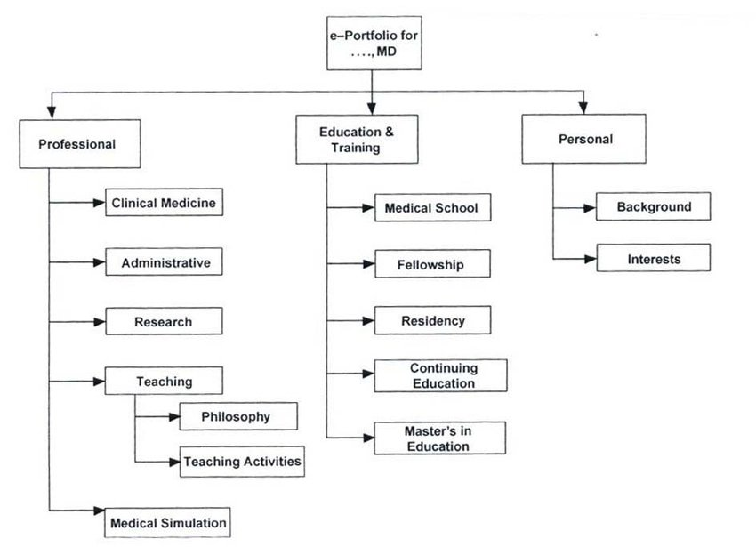

**3.Core concepts used in project:**

* Angular: To develop a front-end application that includes a sign up page, a sign in page, and a landing page
* Git: To connect and push files from the local system to GitHub
* GitHub: To store the Angular application

**4.Conclusions:**

This project is designed to Create Your Amazing Portfolio using Angular.